Contents

Game Design Document 1

Game Story 1

Character 1 2

Menus 2

Main menu 2

Game 3

Game over 4

Game Elements 5

Weapon Script 6

Enemies 7

Map plan 8

Game Breakdown 8

ITCH.IO elements 9

# Game Design Document

Student number: 10621871

Game Name: Prison Outbreak

# Game Story

The world is in turmoil, after the ice caps melted the world sank underwater, now land is highly sought after to feed the re-growing population for the two remaining governments, the east and the west. After the melting polar caps allowed scientists to discover a hidden alien artefact in the ice a strange element was found inside. Scientists believed by exposing humans to various strains of the molecule they could create a more powerful solider to help the ongoing war for land. An underwater prison is set up as a front to house POWs and to secretly experiment on prisoners with the molecule without causing further civil unrest from the already rebellious citizens of the new world.

The game starts when a rouge strain of the molecule causes infected humans to break out of their containment and assault the guards and scientists. The player must defend himself from the zombie onslaught with a weapon he’s picked up from a mutilated guard during the chaos of the initial prison riot.

# Character 1

Daniel Hurt escaped his cell during the riot, during the commotion he was able to take a gun from a guard’s corpse and utilise it as a weapon to protect himself.

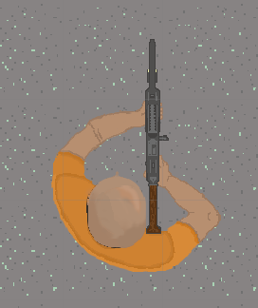

# Menus

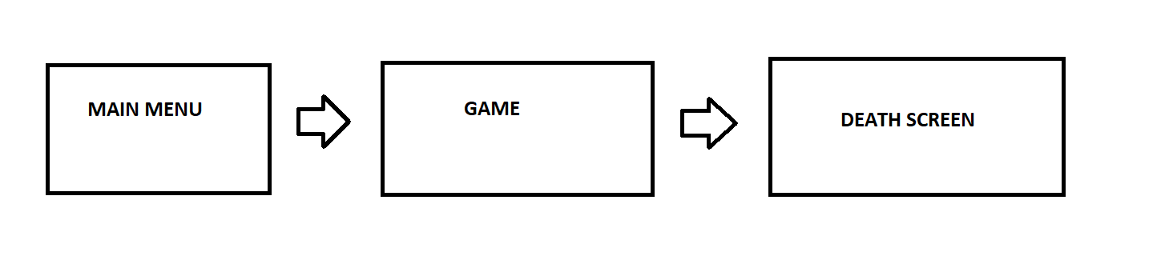

## Main menu

Contains two buttons: start game that loads the game and exit that closes the application.

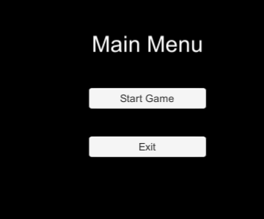

The main menu with have some atmospheric music, that will hopefully set the tone of the game to be serious and suspenseful.

## Game

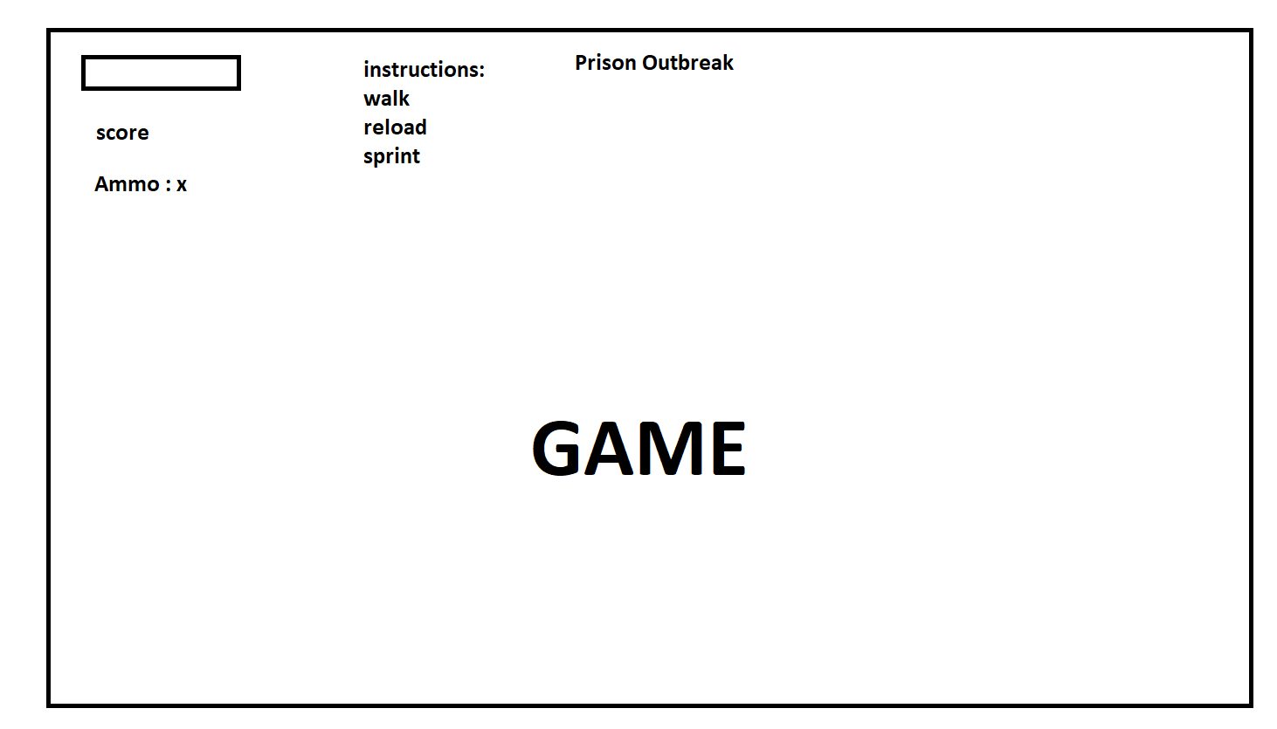

Player health bar will move down and while a zombie is colliding with the player, its represented as a slider that will move down, once it reaches 0 the game with end.

Player score will go up in 10-point increments as a zombie is killed.

Ammo will decrease when a bullet is shot, when it reaches 0 shooting is disabled until the player manually reloads by pressing R.

Sprinting will increase movement to a specific value. Defaulted at 7.

## Game over

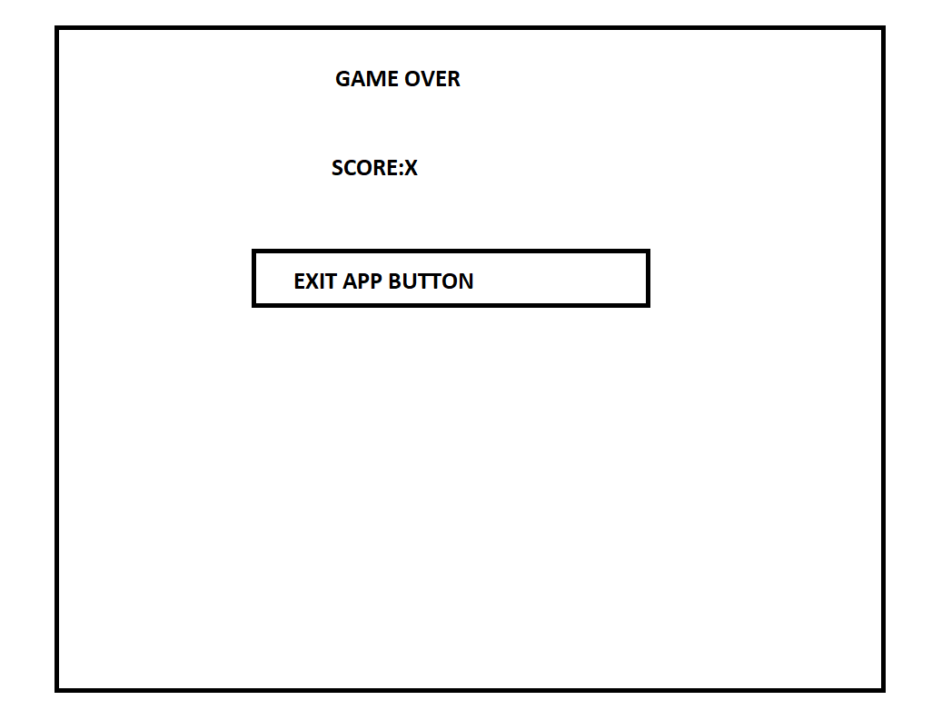

Game over title, under will be some flavour text “you were consumed”.

Shows the players score.

Button to close the game.

# Game Elements

Main Player

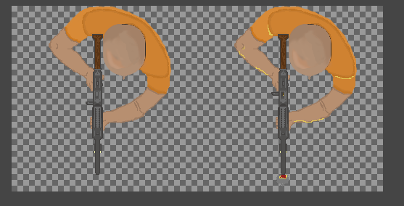

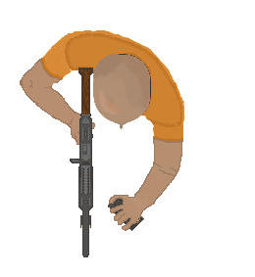

Three graphics are used. Daniel is a prisoner, so he wears a prison jumpsuit, typically orange. We see him in an idle stance, the just fired, where the mechanism on the gun fires back and his arms and torso gets lit up from the muzzle flash, as well as some small fire and smoke appearing at the barrel for dramatization.

The reload animation has one image. Although basic, the idea is conveyed accurately. He goes idle to reloading making it seem like he’s pulling a mag out and placing it in again.

|  |  |  |
| --- | --- | --- |
| Property | Description | Type |
| Health | Once the player takes enough damage the game will end | int |
| Speed | How fast the player moves | Int |
| Sprint speed | Dictates how fast sprint speed is, will always have to be higher than speed | int |
| smoothing | Rotation speed | float |

## Weapon Script

Daniel will hold an assault rifle; the inspiration isn’t based on reality, but it’s designed to be believable enough, so the player understands what it is. It shoots rounds big enough to be seen and fast enough, so the player doesn’t have to lead their shots in close combat.



|  |  |  |
| --- | --- | --- |
| Property | Description | Type |
| Fire time | How quickly the player shoots | Float |
| Mag size | The max ammo the player can shoot before having to reload | Int |
| Current ammo | How many rounds are in the mag | Int |
| Reload time | How long it takes before the player can start firing again. | Float |
| Damage | How quickly it decreases enemy health | Int |
| Speed | Determines simulated velocity | float |
| Destroy time | How quickly unity removes the object for optimization | float |

## Enemies

sprite of a zombie edited to have an orange top because it’s a zombie prisoner.

I am using Astar pathfinding and several components that allow for accurate enemy movement within the map boundaries.

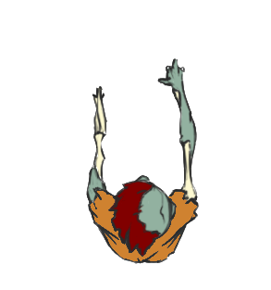

|  |  |  |
| --- | --- | --- |
| Property | Description | Type |
| Health | The zombie’s health – pairs with the damage of the bullet to determine how strong or weak the zombie is | Int |
| Damage | Pairs with the health of the player to lower their hit points while in contact | Int |
| Speed | How fast the zombie moves | Float |
| Score | Determines amount of points the player gets per kill. | Int |

# Map plan

Red circles are marked as zombie spawn areas

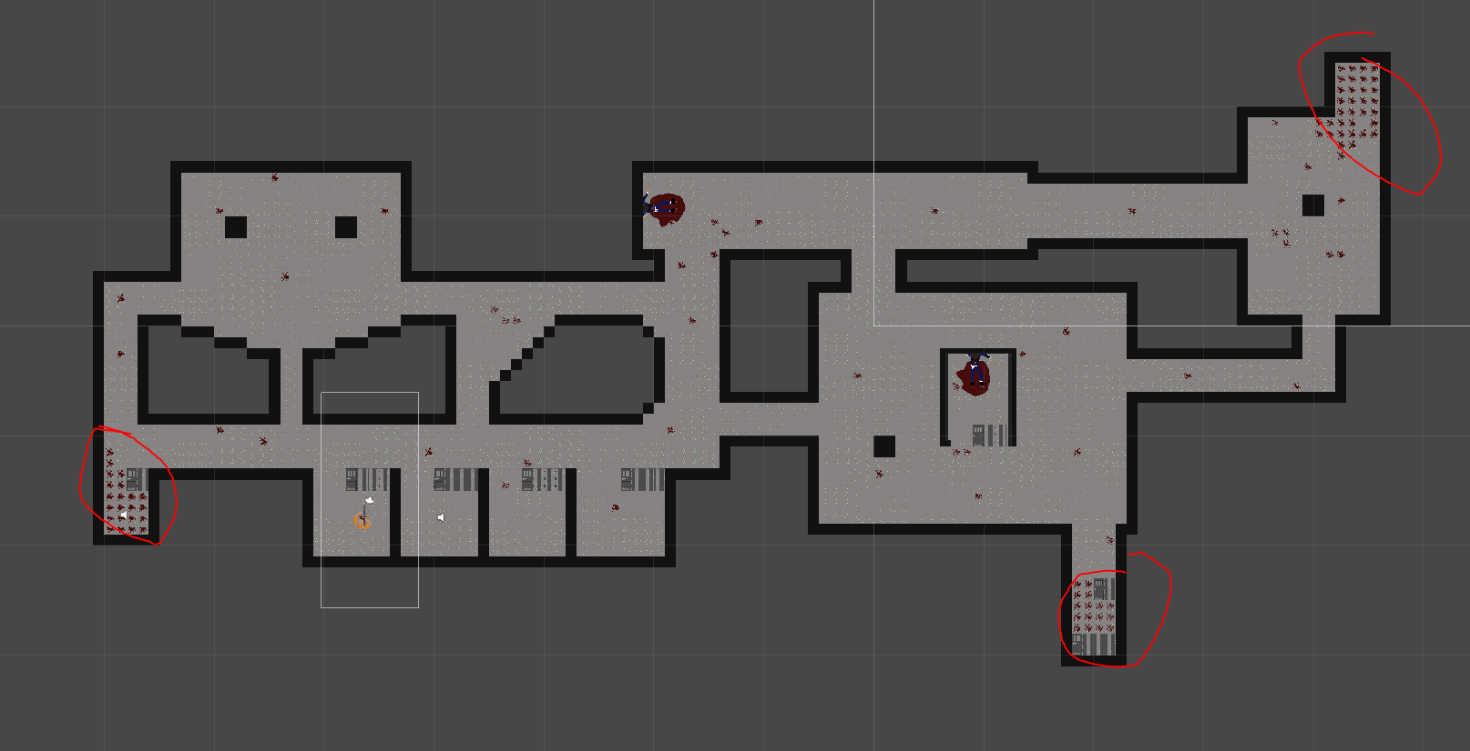

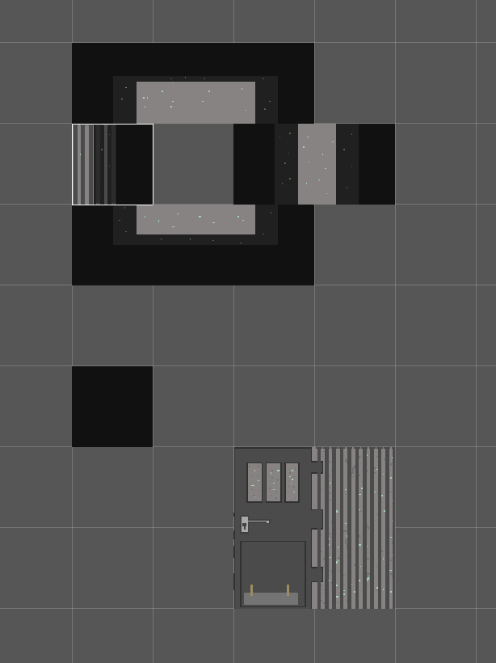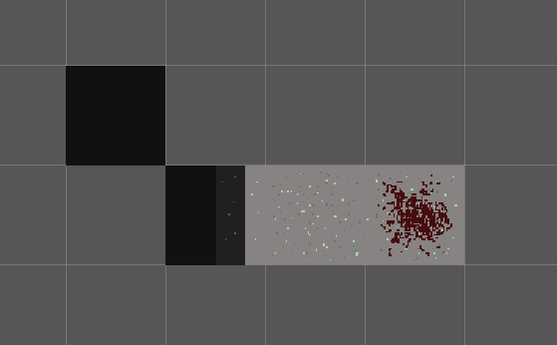

# Game Breakdown

The game is a top down shooter, the player moves along a 2D plain to navigate around the map, the map was designed to have tight corners for intense chases but wider areas for brief moments respite, this is to mimic enclosed space but echo communal environments found in prisons. The goal is to kill zombies while avoiding them and managing ammo.

The player has a variety of controls to use:

* W, A, S, D to move
* R to reload
* SHIFT to sprint
* The mouse is used to rotate the player
* LMB is shoot

# ITCH.IO elements

Screen Shot of the game

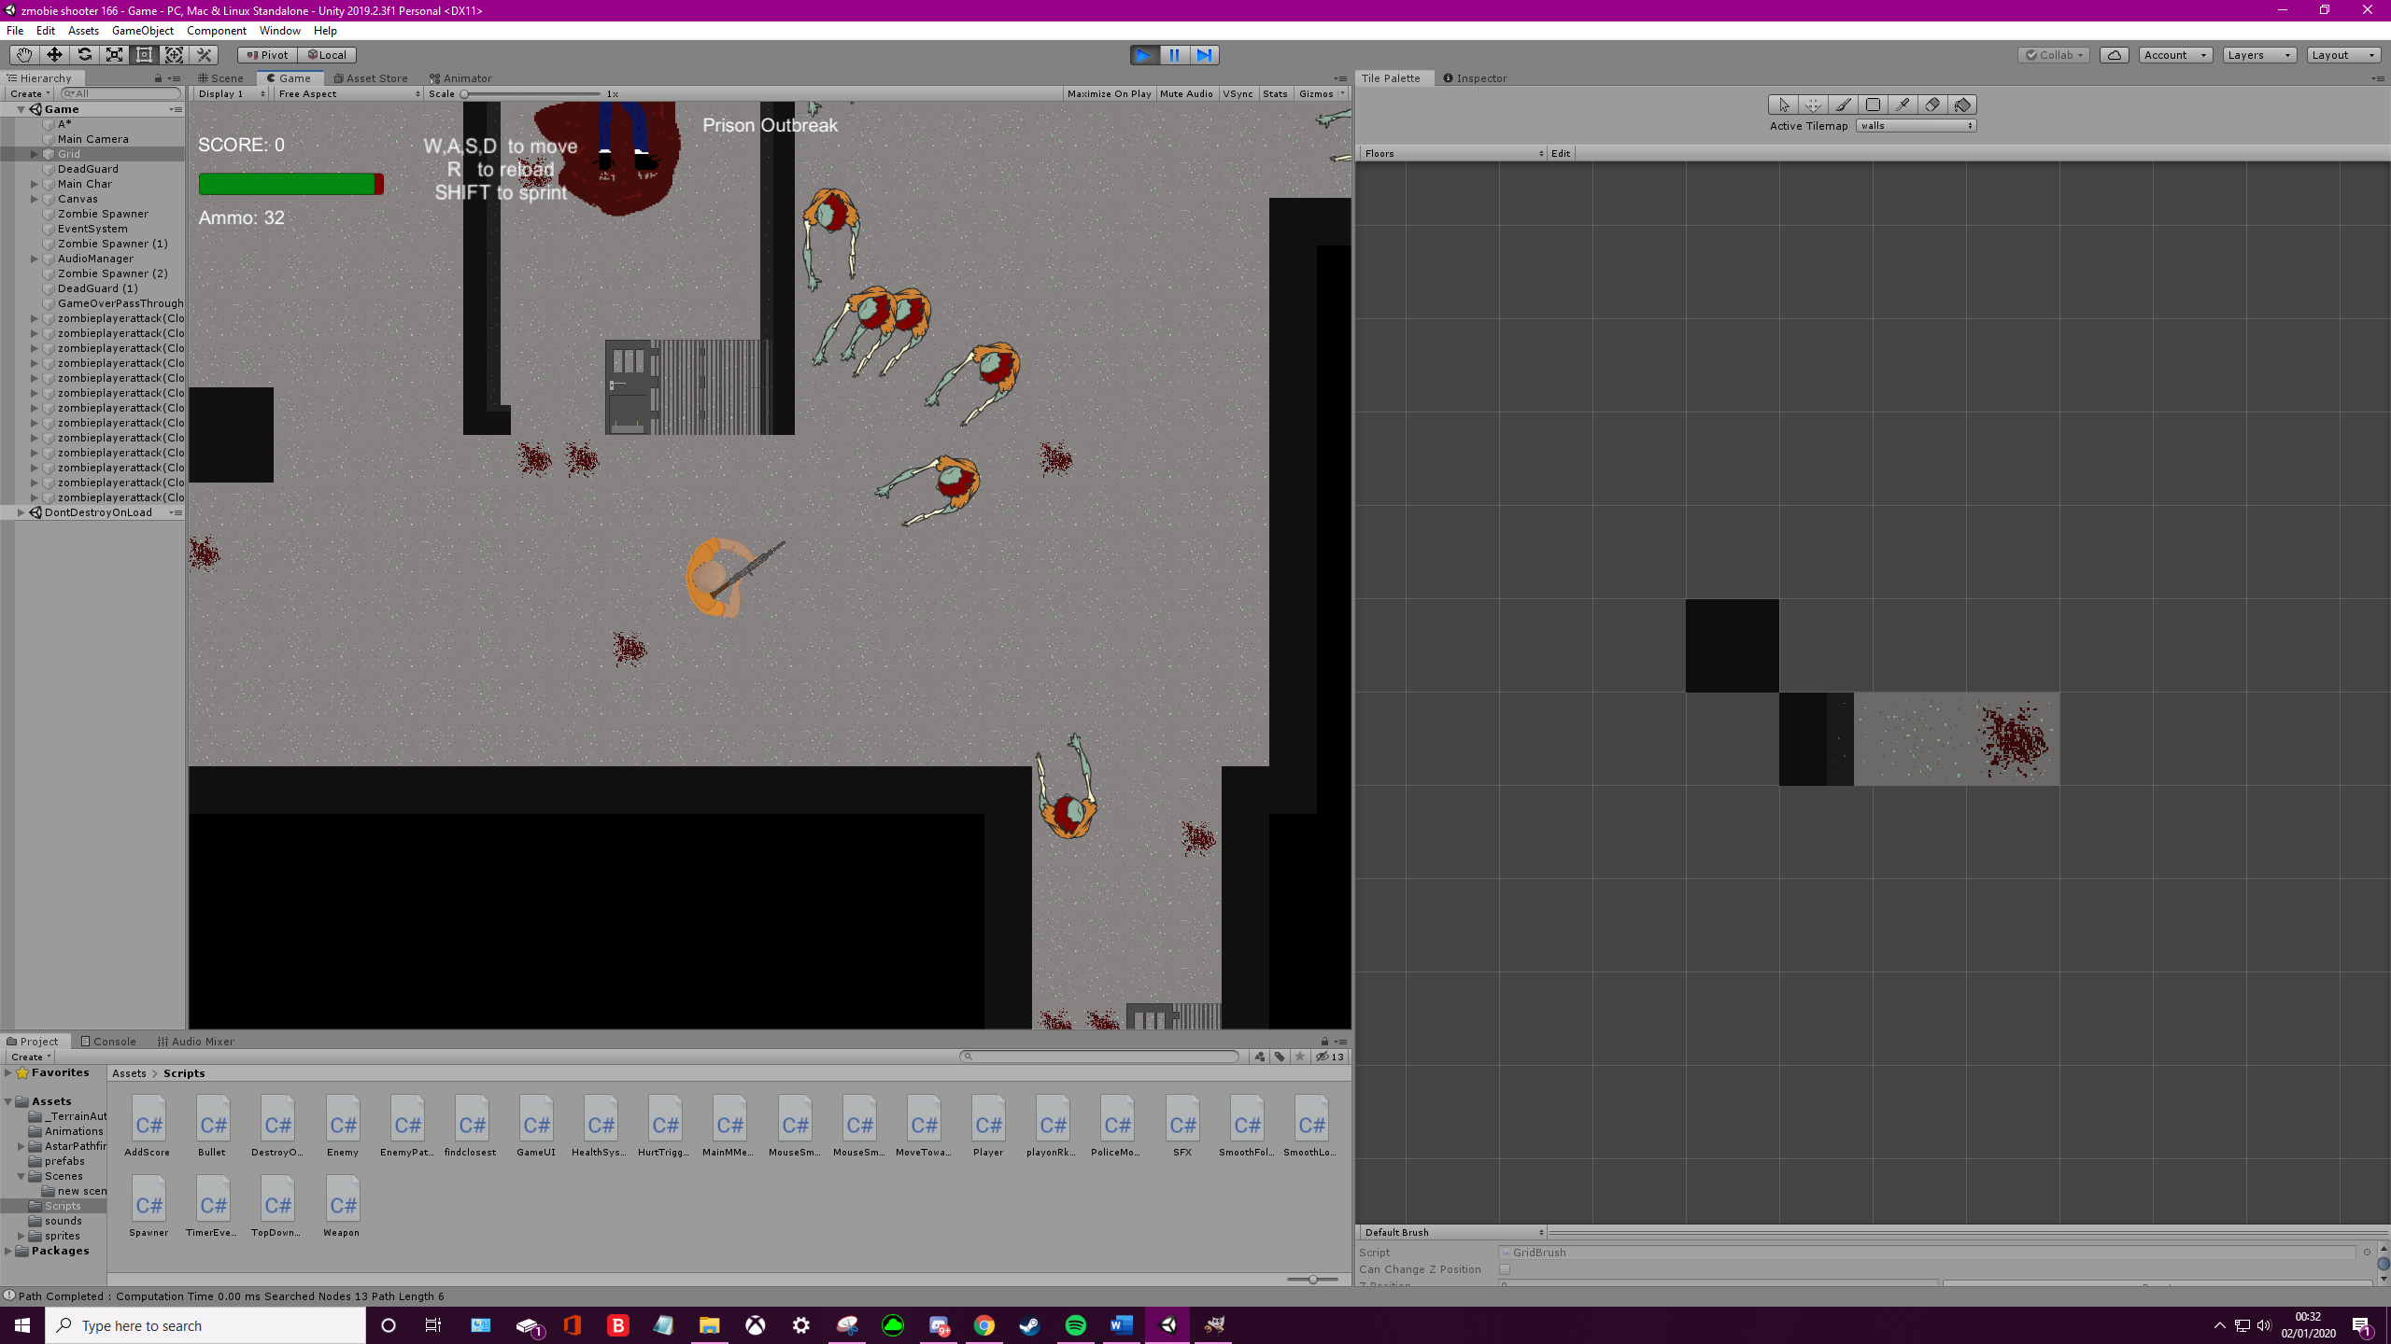

Itch.io username Logo “TheLetterPurple”

